2004

THIS PAGE HAS BEEN LEFT BLANK INTENTIONALLY

PART I (80 Marks)

Mark your answers to Questions 1–40 on the SEPARATE MULTIPLE CHOICE ANSWER SHEET, using a 2B, B or HB pencil. If you make an error, follow the instructions given to you on the answer sheet.

SELECT THE SINGLE CORRECT ALTERNATIVE IN EACH OF THE FOLLOWING QUESTIONS

Questions one, two and three refer to the diagram below.

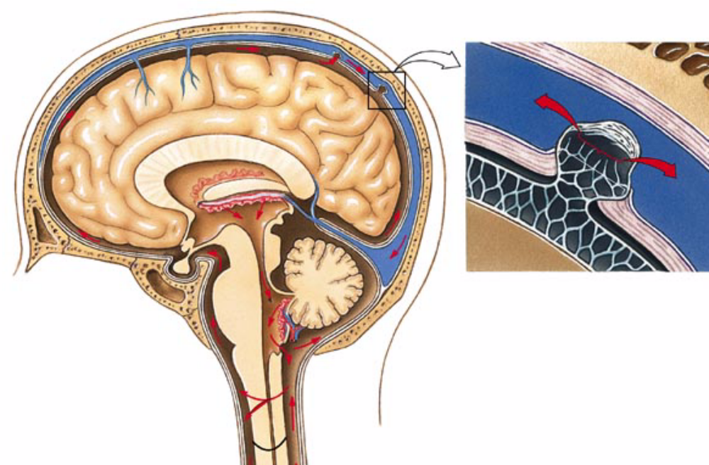
C
B
A

1. Which of the following is NOT true of structure A?

(a) It is surrounded by three layers of meninges.
(b) Information from the body terminates in structure A’s white matter.
(c) Its surface is convoluted to provide greater surface area.
(d) It is connected to, and able to influence, the cerebellum.
2. This question refers to the list of features below.

(i) regulation of osmotic balance
(ii) regulation of the heart rate
(iii) coordination of posture and movement
(iv) temperature control

Which of the above features are roles played by structure B?

(a) (i), (ii) and (iii) only
(b) (i), (ii) and (iv) only
(c) (i), (ii), (iii) and (iv) only
(d) (ii) and (iv) only

3. Which of the following statements is true of the fluid contained in
structure C?

(a) It is produced by the meninges.
(b) It has an important role in protecting the brain from infection.
(c) It assists with nourishment of the cerebral cortex.
(d) It assists with temperature regulation in the brain.

4. Which of the following statements is true?

(a) Nerves are slower than hormones when responding to a stimulus.
(b) Some hormones are released by nerves.
(c) Hormones are able to quicken or slow body processes but nerves are only able to quicken body processes.
(d) Nerves produce long-lasting effects but responses to hormones are short-lived.

5. Which of the following statements is correct?

(a) The sensation of touch is processed in the cerebellum.
(b) The ventral root of a spinal nerve contains sensory neurons.
(c) The dorsal root ganglia contains the cell bodies of many motor neurons.
(d) Following the response, reflex actions are interpreted by the cerebrum.

6. The neuron illustrated below would be classified correctly as

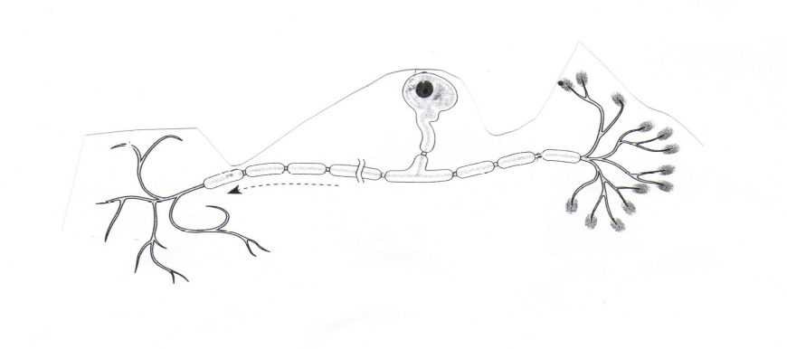

(a) a sensory neuron.
(b) a motor neuron.
(c) a connector neuron.
(d) there is not enough information to say.

7. A virus is injected into an animal and the animal is then left to fight the infection by making antibodies to the virus. The antibodies can then be removed from the animal and injected into a human who is infected with the same virus. This is an example of

(a) natural immunity.
(b) passive immunisation.
(c) innate immunity.
(d) active immunisation.

8. Which of the following statements about a new-born baby and the immune system is correct?

(a) The baby has yet to develop a non-specific immune system.
(b) The baby’s specific immune system has been exposed to many foreign antigens.
(c) The baby has some specific immunity from anti-bodies that have crossed the placenta.
(d) The baby has developed active immunity from antigens that have crossed the placenta.

9. Which of the following statements regarding humans and pongids is correct?

(a) Humans and pongids possess a large lumbar curvature.
(b) Humans possess one arch in the foot while pongids possess two foot arches.
(c) Humans have a large area on their skull for the attachment of large neck muscles, but pongids show little development in this area.
(d) Pongids have an opposable big toe while humans do not have an opposable big toe.

10. Which of the following sets of traits are found in the Homo erectus?

(a) cranial capacity approximately 1400 cm³, use of hand axe, occipital bun and reduced canines.
(b) bipedal locomotion, reduced canines, reduced molar number and cranial capacity approximately 1000 cm³ .
(c) bipedal locomotion, cranial capacity approximately 700 cm³, reduced canines and use of fire.
(d) use of hand axe, cranial capacity approximately 1000 cm³ and prominent brow ridge.

11. Select the correct statement about the evolution of humans.

(a) Widely varying fossils considered to be Homo erectus are found in Africa and in Asia but not in Europe.
(b) Neanderthals arose in North Africa and were the first hominids to colonize Europe.
(c) Homo erectus was the first hominid to colonise habitats outside of Africa.
(d) All Australopithecine fossils are dated to before the appearance of Homo.

This question refers to the skull illustrated below.
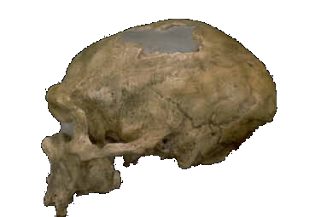

2.5 cm

12. To which of the following groups does this skull belong?

(a) Neanderthals
(b) modern humans
(c) Homo erectus
(d) an Australopithecine

Questions 13 and 14 refer to the skull illustrated below.

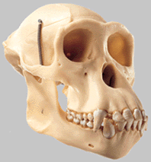

3 cm

13. Which of the following sets of features would be present in the group of which this skull is representative?

(a) cranial capacity of less than 600 cc, large canine teeth, central foramen magnum;
(b) large canine teeth, sagittal crest, prognathic face;
(c) large canine teeth, sagittal crest, nasal bone;
(d) cranial capacity of less than 600 cc, large canine teeth, and prognathic face.

14. Which of the following anatomical features in the above specimen could be used to distinguish this group from humans?

(a) canine teeth, cranial capacity, molar teeth, and foramen magnum;
(b) cranial capacity, molar teeth, and mandible shape;
(c) cranial capacity, mandible shape, and foramen magnum;
(d) cranial capacity, molar shape, and sagittal crest.

15. The Australian Aborigines arrived on the Australian mainland approximately

(a) 1 million years ago.
(b) 20,000 to 30,000 years ago.
(c) 5,000 years ago.
(d) 40,000 to 50,000 years ago.

16. A mother with a blood group phenotype of A could have a child with phenotype O so long as

(a) she is heterozygous and the father is heterozygous.
(b) she is heterozygous and the father has a genotype I^{B}iº.
(c) one of her parents was heterozygous and carried the iº allele.
(d) the father is either I^{A}iº or I^{B}iº.

Questions 17 and 18 refer to the diagram below.

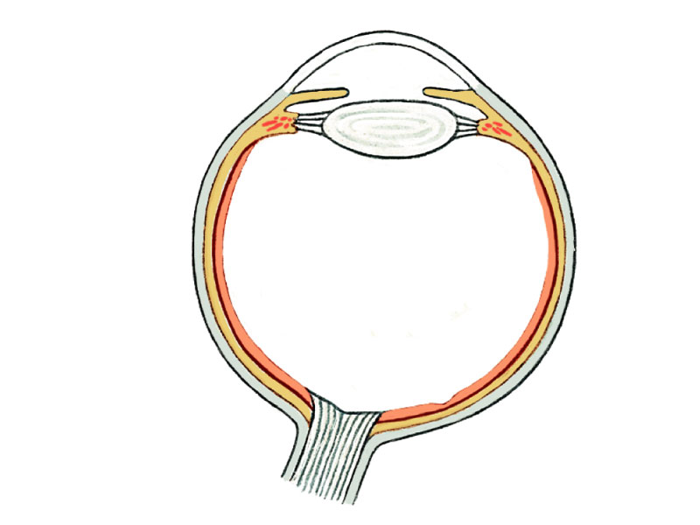
A
B
C

17. The structures labelled A, B and C in the diagram above are respectively

(a) aqueous humor, conjunctiva and sclera.
(b) vitreous humor, cornea and retina.
(c) vitreous humor, cornea and sclera.
(d) sclera, conjunctiva and choroid.

18. In the condition known as Myopia, an object at a distance to the eye will be focussed

(a) in front of the retina because the eyeball is too long.
(b) behind the retina because the eyeball is too short.
(c) on the retina but will appear smaller.
(d) on the retina but will appear unclear.

19. An individual’s heart rate will decrease if it is stimulated by

(a) the parasympathetic nervous system.
(b) adrenalin.
(c) the sympathetic nervous system.
(d) the hypothalamus.

20. When dating fossils, the Law of Superposition states that

(a) accurate levels of radio-isotopes must be obtained.
(b) older fossils occur in deeper layers of rocks.
(c) fluorine levels are highest in old fossils.
(d) older fossils are not as well preserved as younger fossils.
21. The half-life for Carbon-14 is 5,730 years. How much of the original Carbon-14 is left in a fossil specimen that is dated at 17,190 years?

(a) 12.5%
(b) 25%
(c) 50%
(d) 75%

Questions 22, 23 and 24 refer to the diagram below.
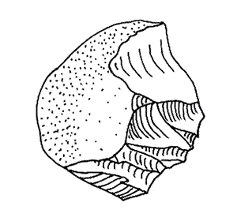

22. With which fossil hominid is this tool associated?

(a) Homo neanderthalensis
(b) Homo erectus
(c) Homo habilis
(d) Early Australopithecine

23. The approximate date for this tool would most probably be

(a) less than 500,000 years ago.
(b) between 500,000 and one million years ago.
(c) between two and three million years ago.
(d) greater than three million years ago.

24. This tool would best be dated to an absolute date by

(a) measuring the amount of fluorine left in the tool.
(b) stratigraphy in which the bones associated with the tool are compared to similar bones in other areas.
(c) using radiocarbon dating on the bones associated with the tool.
(d) using potassium-argon dating on the soil layers surrounding the tool.

THIS PAGE HAS BEEN LEFT BLANK INTENTIONALLY

Question 25 refers to the information presented below.

Free-diving is an Extreme sport in which divers hold their breath for long periods of time and dive to great depths. An investigation into the effect that such a dive has on breathing rate was performed.

The data collected for breathing rate are shown below.

1
8
6
5
3
2
7
4
11
10
9
40
30
20
10
Time (min)
Breathing Rate for a Free Diver
Breathing
Rate
(breaths/min)

25. Examine the graphs drawn below. Which of the graphs best represents the change in carbon dioxide levels in the blood during the free dive investigation?

(a) Graph A
(b) Graph B
(c) Graph C
(d) Graph D

Note: The Y-axis represents levels of Carbon Dioxide in the blood.

Graph A
1
2
3
4
5
6
7
8
9
10
11
Time (min)
Graph B
1
2
3
4
5
6
7
8
9
10
11
Time (min)
1
2
3
4
5
6
7
8
9
10
11
Graph C
Time (min)
1
2
3
4
5
6
7
8
9
10
11
Graph D
Time (min)

Questions 26 and 27 refer to the graph below.

ATMOSPHERIC CO₂ LEVELS DUE TO INDUSTRIAL EMISSIONS
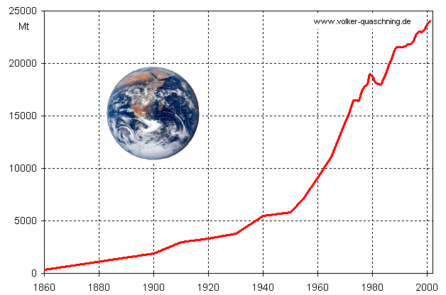
CO₂
Levels
(Mt)
Year

26. The period in which industrial emissions were increasing most rapidly was

(a) 1940 to 1960
(b) 1982 to 1985
(c) 1985 to 2000
(d) 1920 to 1960

27. If a measure of total global CO₂ in the atmosphere was made in 1960, the measure would be

(a) slightly less than 10,000 Mt.
(b) the sum of all of the point values from 1860 to 1960.
(c) more than 9,000 Mt but unclear how much more.
(d) an average of the values between 1950 and 1970.

28. This question refers to the list of statements below.

(i) Chlorofluorocarbons contribute to ozone depletion.
(ii) Deforestation increases atmospheric CO₂ levels and desertification.
(iii) Fossil fuel consumption increases CO₂ leading to higher skin cancer rate.
(iv) Untreated sewage runoff results in plant deaths.
(v) Heavy metals in fertilizer runoff results in salinisation.
(vi) Fertilizer runoff increases heavy metal concentrations and the incidence of cancer.

Which of the above statements reflect true relationships between human activities and the effects of pollution?

(a) i, ii, and iv only
(b) i, iii, and iv only
(c) ii, iii, and vi only
(d) i, ii, and vi only

29. Which of the following is a direct consequence of ozone depletion in the atmosphere?

(a) Increased penetration of ultra-violet radiation.
(b) Increased global temperatures.
(c) Changing distribution of rainfall.
(d) Increased crop yields.

30. Which of the following is NOT an argument that supports the widespread use of recycling?

(a) It will conserve non-renewable resources.
(b) Large land-fill sites may lead to contamination of soil.
(c) It is the cheapest alternative for processing urban refuse.
(d) Compared with raw materials, recycled materials require less energy in the manufacture of useful products.

Questions 31 and 32 refer to the diagram below.

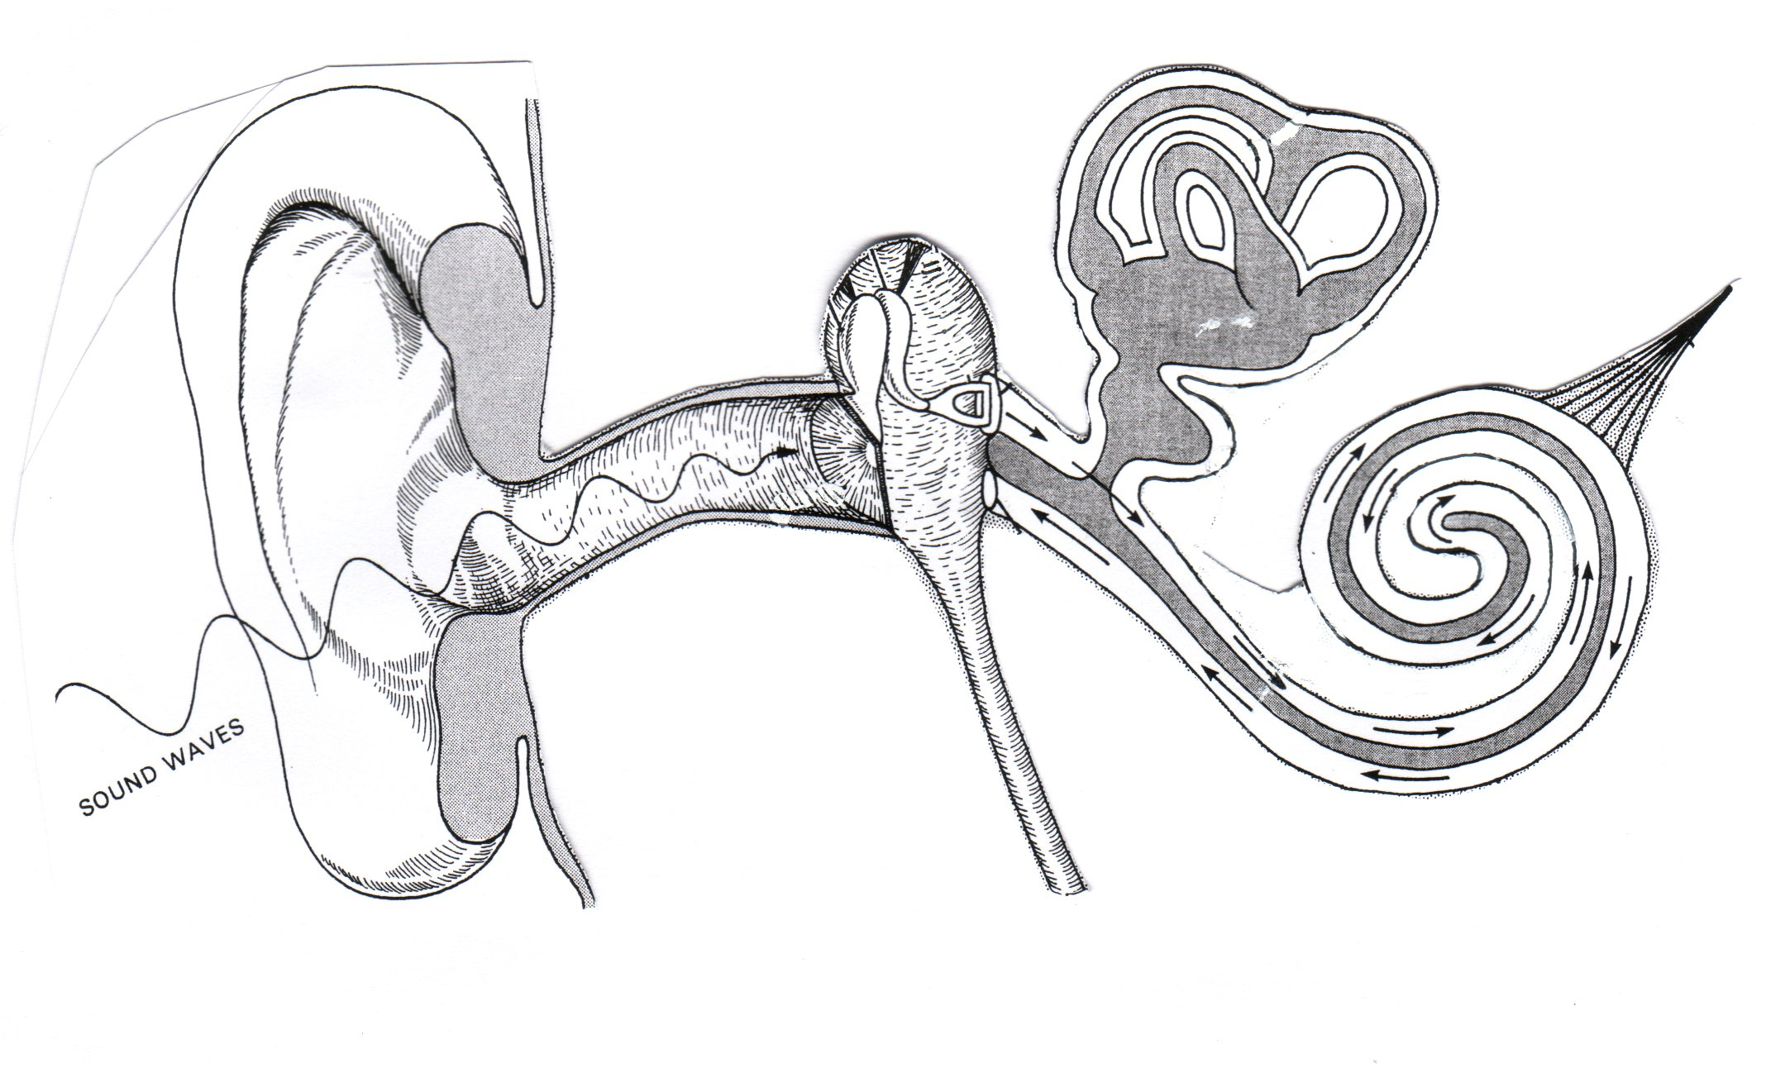
A
D
B
C

31. After stepping off an amusement park ride which involves spinning around, a person may experience dizziness because

(a) the otoliths in structure D continue to move around.
(b) the fluid and sensory hairs in structure C are disturbed by the spinning motion.
(c) structure A can be pulled free from the inner ear.
(d) structure B overstimulates the cerebrum.

32. Factory workers who have spent many years working next to loud machinery will be able to hear low frequency sounds but will experience some difficulty hearing sounds that are at a high frequency. This is because

(a) the loud noises may have permanently fractured structure A.
(b) some of the sensory hairs in structure C have been damaged.
(c) loud noises can scar the sensory cells that line structure B.
(d) scar tissue in structure D may interfere with its normal function.

Questions 33, 34 and 35 refer to the information below.

The diagram below indicates part of an image viewed down a microscope. Three different fluid compartments within a small sample of human tissue are shown. Also provided are data on the concentration of total dissolved substances within these compartments.

Blood Plasma
(135 mg/L)
Intra-Cellular Fluid
(98 mg/L)
Inter-Cellular Fluid
(105 mg/L)

33. In the absence of any cell activity, which of the following statements is true?

(a) Water will leave the blood plasma and the cells will swell.
(b) The cells will shrink as water leaves and moves into the blood plasma.
(c) Water will move into the plasma and out of the plasma at an even rate.
(d) The inter-cellular fluid will absorb excess water and protect the cells from swelling.

34. If it is important for the cells to maintain these concentration differences then the cells

(a) must use energy to move water into the blood plasma.
(b) must use energy to move dissolved substances into themselves.
(c) must use energy to move dissolved substances into inter-cellular fluid and then into the blood plasma.
(d) must use phagocytosis to eliminate water.

35. If you were asked to measure the size of these cells, which piece of information would be most useful?

(a) The field of view.
(b) The magnification of the image.
(c) The number and size of lenses in place.
(d) The type of cells being viewed.

36. This question refers to the list of statements below.

(i) The fossil record has some specimens that form a link between modern varieties of some species.
(ii) Animal breeders are able to produce a large number of different breeds.
(iii) DNA analysis demonstrates that related species show much similarity in the sequence of their DNA.
(iv) The upper limb of many vertebrates display similar patterns.

Which of the above statements provide evidence to support the theory of evolution?

(a) (i) and (ii) only
(b) (i), (ii) and (iii) only
(c) (i) and (iv) only
(d) (i), (ii), (iii) and (iv)

37. Compared to an agricultural society, a hunter-gatherer society will most likely

(a) require less land to meet requirements.
(b) have greater specialisation of labour.
(c) have less impact on the environment.
(d) consume greater resources per person.

Questions 38, 39 and 40 refer to the information below.

Malaria is a disease caused by a single-celled animal from the genus Plasmodium. It lives in the blood and can seriously affect liver function. Humans can become infected with malaria when they are bitten by a mosquito that has obtained blood from a malaria sufferer.

In certain areas of Africa, some people are protected from the effects of malaria because they have inherited a Co-Dominant genetic condition called Sickle Cell Anaemia. Because of this protection, the incidence of Sickle Cell Anaemia in these areas is much higher than in other parts of the world.

38. Using this information, the vector for malaria is

(a) the affected malaria sufferer bitten by the mosquito.
(b) the mosquito.
(c) the plasmodium in the sufferer’s blood.
(d) the liver.

39. A Co-Dominant genetic condition is one in which

(a) the heterozygote shows the effect of two different alleles.
(b) there are two possible ways to combine alleles.
(c) the homozygote has inherited different alleles from each parent.
(d) one allele completely hides the effect of another allele.
40. The selective pressure that has resulted in the high incidence of Sickle Cell Anaemia in these areas is

(a) the co-dominant gene.
(b) the Sickle Cell Anaemia.
(c) the people that carry the Sickle Cell Anaemia condition.
(d) the Malaria.

END OF PART I

PART II (80 Marks)

Write answers to ALL questions on the ruled lines after each question or in the spaces provided within each table. Write your answers in blue or black ballpoint or ink pen.

Question 41 (Total 8 marks)

Examine the population data for a country presented in the graph below.

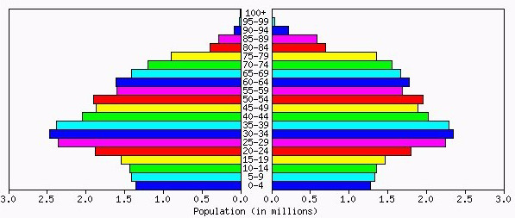
MALE
FEMALE

- Apart from sex, what data have been used to construct the population pyramid above?

(2 marks)

(b) How many people in this country are under 10 years of age?

(1 mark)

(c) What can you say about the stage of development in this country?

(1 mark)

(d) What is the reason for your answer in part (c)?

(1 mark)

(e) Based on this current population structure, predict two problems that will confront this country in 40 years time.

(2 marks)

(f) If this population trend continues, provide a sketch of what you would expect the population pyramid for this country to look like in 40 years.
(1 mark)

Question 42 (Total 11 marks)

The diagram below represents a longitudinal cross-section through the human kidney.

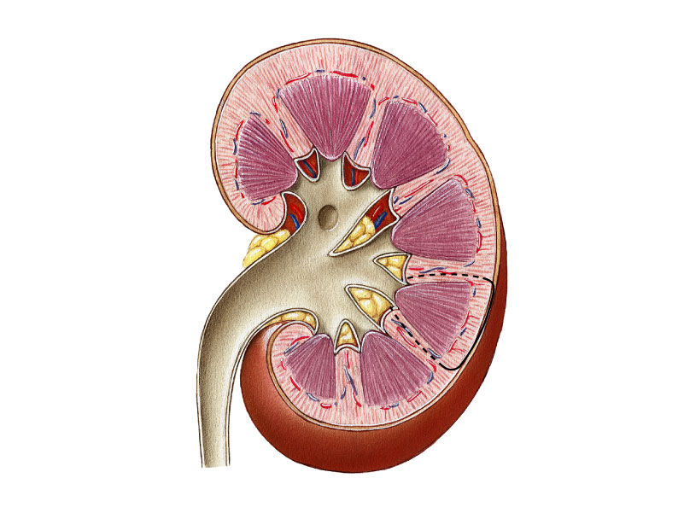
STRUCTURE A
STRUCTURE B
REGION 1

(a) Identify the structures labelled A and B.

A:
B:
(2 marks)

(b) Which part/parts of a nephron are found in region 1?

(1 mark)

To answer (c) (d) and (e) refer to the structure shown on the opposite page in which the dotted arrows indicate the direction of blood flow.

(c) Identify the structures labelled C and D.

C:
D:
(2 marks)

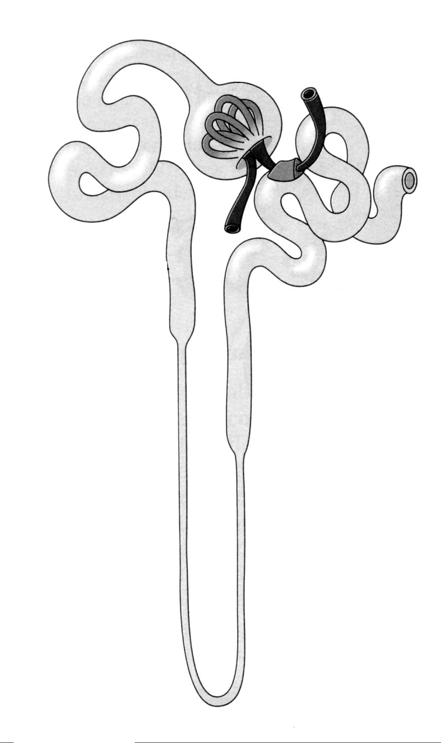
D
C

(d) What is the next, immediate destination for the blood from structure C?

(1 mark)

(e) Explain the process by which structure D influences urine composition.

(3 marks)

(f) In what way does the release of ADH influence the composition of urine? Explain how it achieves this influence.

(2 marks)

Question 43 (Total 13 marks)

As the scientist on duty in a regional hospital you receive a sample of Cerebrospinal Fluid (CSF). You are asked to test the sample for a bacterial infection, which you find, and then you are asked to determine the best form of treatment.

As a young scientist you are keen to investigate a drug company’s hypothesis that:

“Our new drug 44-Maxophage improves the action of antibiotics.”

(a) When designing an experiment to test this hypothesis, what would be

(i) the independent variable?

(ii) the dependent variable?

(iii) two control variables?

(4 marks)

In order to test the hypothesis, you grow the bacteria cells in a series of petri-dishes containing essential nutrients. The results of your experiment are shown in the table below.

- A negative (–) indicates that the antibiotic had no effect.
- A positive (+) indicates that the antibiotic destroyed the bacterium.

Note: At higher concentrations, antibiotics can harm the cells of the body.

Antibiotic  Concentrate | Petri Dish 1 | Petri Dish 2 | Petri Dish 3 | Petri Dish 4
Antibiotic  Concentrate | Antibiotic A  only | Antibiotic A  and  44–Maxophage | Antibiotic B  only | Antibiotic B  and  44–Maxophage
100 mg/ml | (+) | (+) | (+) | (+)
50 mg/ml | (+) | (–) | (+) | (+)
25 mg/ml | (–) | (–) | (+) | (–)
10 mg/ml | (–) | (–) | (–) | (–)

(b) Do the results presented in the table support the drug company’s hypothesis? Use data from the table to support your answer.

(2 marks)

(c) Of the four treatments, which would you MOST LIKELY recommend to treat the bacterial infection? Why?

(2 marks)

(d) What was the purpose of setting up Petri Dishes 1 and 3?

(2 marks)

(e) Identify another hypothesis that these data could be used to evaluate.

(1 mark)

(f) What are TWO ways that antibiotics destroy bacterial cells?

(2 marks)

Question 44 (Total 9 marks)

Two men (A and B) were studied in a laboratory setting over a period of two hours. The men were placed in a 40°C environment until their oxygen consumption stabilised. The environmental temperature was then slowly decreased by 10°C every 30 minute period. These environmental temperatures are indicated on the X-axis in the graph below.

Oxygen Consumption in Response to Decreasing Environmental Temperature

Oxygen
Consumption
(L/min)
A
B
0
(40°C)
30
(30°C)
60
(20°C)
90
(10°C)
Time (min)
50
40
30
10
20

- Identify the chemical process within cells that brings about the major change shown in the graph above. Why is this useful to the subjects?

(2 marks)

(b) Identify TWO other physiological changes that may occur in the subjects when the environmental temperature falls below 10°C.

(2 marks)

(c) Which individual is most likely to be endomorphic? Use evidence provided in the graph to support your answer.

(2 marks)
(d) Why does an endomorph respond this way?

(2 marks)

(e) On the axes provided below, draw a graph that would represent the change in core body temperature for individual A between 30 minutes and 90 minutes.
Time (min)
Core Body
Temperature
(°C)

(1 mark)

Question 45 (Total 11 marks)

The model illustrated below helps describe the initiation and maintenance of the second half of the human ovarian/menstrual cycle beginning just prior to ovulation. Examine this model carefully and answer the questions below.

RECEPTOR

TARGET ORGAN

PITUITARY

RESPONSE
LH

(a) In this model, identify the:

(i) Receptor

(ii) Target Organ
(2 marks)

(b) Identify two responses of the target organ to LH.

(2 marks)

(c) Describe one effect of this response on the uterus.

(1 mark)

(d) Describe how the response of the target organ would alter ovarian hormone levels in the blood.

(2 marks)
(e) Describe and explain the process by which the beginning of the next ovarian cycle is initiated and a new follicle begins to develop.

(4 marks)
Question 46 (8 marks)

The pedigree shown below represents the inheritance of a genetic condition that affects normal vision. A student examined this pedigree and concluded that the condition must be inherited in an autosomal fashion. On the basis of this information, answer the questions below. In your analysis, use the letters N or n.

1
5
2
2
1
3
4
6
7
5
2
4
1
3
I
II
III

(a) What is the probability that individual III-4 is heterozygous? Show your working.

(2 marks)

(b) List all the individuals for whom genotype is uncertain.

(2 marks)

(c) If individual III-2 married and had children with an affected person, what is the chance that their child will have the condition? Show your working.

(2 marks)

(d) A second student examined this pedigree and made the statement:

“There is evidence on the pedigree that this condition could also be inherited as a sex-linked recessive condition”.

Is this statement correct or incorrect? Use evidence from the pedigree to support your answer.

(2 marks)

Question 47 (10 marks)

The human body is under the influence of a range of chemicals. These chemicals may be produced by the body itself to help co-ordinate normal functioning or may be introduced as drugs designed to alter, or in some cases assist, normal functioning.

(a) Describe the effect of T.S.H. on the rate of metabolism AND describe the hormonal response by which it causes this effect.

(2 marks)

(b) Describe the effect of alcohol on the volume of urine AND describe the hormonal response by which it causes this effect.

(2 marks)

(c) Describe only, the influence of:

(i) prolactin (lactogenic hormone) on milk production.

(1 mark)

(ii) low doses of marijuana on the Central Nervous System.

(1 mark)

(iii) nicotine on blood vessels.

(1 mark)

(iv) heroin on the sympathetic Autonomic Nervous System.

(1 mark)

(d) Apart from their physiological effects, drugs can have an impact on society and culture. Consider the drug heroin and list TWO social effects brought about by the widespread use of this drug.

(2 marks)

Question 48 (10 marks)

It is estimated that the global human population was relatively stable or increased very slowly for tens of thousands of years prior to the Neolithic revolution. Following this event, the population increased rapidly and cultural innovations accelerated.

(a) Approximately, what date is given for the beginning of the Neolithic revolution in the Middle East region?

(1 mark)

(b) Identify three features of the Neolithic revolution that provided for rapid cultural advances.

(3 marks)

(c) Anthropological studies of this time require the examination of fossil remains. Identify TWO environmental conditions that are required to produce good fossil specimens.

(2 marks)

(d) While rapid human population increase has contributed to the extinction of many species, it has also contributed to increases in the populations of others.

Identify two mechanisms by which human population increase has resulted in the extinction of other species and two mechanisms by which human population has increased the numbers and/or distribution of other species.

Species Extinction:

Species Increase:

(4 marks)

END OF PART II
PART III (40 Marks)

Answer ONE question from SECTION A and ONE question from SECTION B. Illustrate your answers with diagrams where appropriate. Up to TWO MARKS may be deducted for poorly structured answers: that is, answers in point form or diagrams not explained in the text of your answers. DO NOT WRITE ANSWERS IN PENCIL. Write your answers on the lined pages in your Question/Answer Booklet following the end of the questions.

SECTION A

ANSWER EITHER QUESTION 49 OR QUESTION 50 – NOT BOTH

QUESTION 49 (Total 20 marks)

(a) Explain how the humoral immune system acts to neutralise a foreign body.
(10 marks)

(b) Human Immunodeficiency Virus (HIV) is known to be the cause of AIDS. Describe the mode of transmission for this disease and explain how HIV suppresses/affects the body’s immune system, making the body susceptible to infection.
(10 marks)

OR

QUESTION 50 (Total 20 marks)

Homeostasis is the maintenance of a relatively constant internal environment within the body. In order to survive, living cells must be bathed in a fluid whose properties are not allowed to vary beyond certain limits.

(a) Describe the roles played by the pancreas and the liver in the homeostatic control of sugar levels.
(10 marks)

(b) Describe the role played by the autonomic nervous system in the homeostatic control of oxygen levels.
(10 marks)

SECTION B

ANSWER EITHER QUESTION 51 OR QUESTION 52 – NOT BOTH

QUESTION 51 (Total 20 marks)

One physical variation found in human populations is skin colour. Skin colour changes gradually with distance from the equator. This gradual change is called a cline.

(a) Describe this variation in skin colour and discuss the process by which natural selection has established this gradual change.
(10 marks)

(b) Despite the existence of the skin colour cline, there are small populations of people who possess an unexpected skin colour. Discuss the processes by which these ‘unexpected’ populations may have become established.
(10 marks)

OR

QUESTION 52 (Total 20 marks)

When first discovered, the Australopithecines were considered to represent a direct link between the pongids and the genus Homo. This is because Australopithecine fossils demonstrate some features that are like pongids and some features that are like the genus Homo.

(a) Based on fossil evidence, scientists believe that the Australopithecines were bipedal and walked with a striding gait.

Describe four pieces of fossil evidence that supports this belief and for each, explain the advantage to bipedalism that it provides.
(8 marks)

(b) (i) Identify and describe three pongid-like features of Australopithecines that are not related to locomotion.

(ii) Identify and describe three features of Australopithecines, not related to locomotion, that represent a transition towards the genus Homo.
(6 marks)

(c) (i) Describe the date range and geographic distribution for the Australopithecines.

(ii) Suggest two hypotheses for the extinction of the Australopithecines and describe possible evidence for each suggested hypothesis.
(6 marks)

END OF PAPER
Check that you have written your Student Number on the front cover of this booklet.

ACKNOWLEDGEMENTS

Question 1 & 42: Figure modified from: Martini, F.H. (2001). Fundamentals of anatomy and physiology (5th ed.). Upper Saddle River, NJ: Prentice Hall, accompanying CD-ROM.

Question 6: Figure from: Allan, R., & Greenwood, T. (1999). Year 12 Biology (1999) student resource and activity manual. Queensland: Tutor Courseware, p. 50.

Question 12: Figure from: La Chapelle-aux-Saints: The Old Man. (n.d.). Retrieved June, 2004, from the Smithsonian Institution website at: http://www.mnh.si.edu/anthro/humanorigins/ha/lachap.htm

Questions 13 & 14: Figure from: Somso. (n.d.). ZoS 53/107: Artificial skull of a chimpanzee. Retrieved September, 2004, from http://www.somso.de/english/main.htm

Questions 17 & 18: Figure modified from: Martini, F.H. (2001). Fundamentals of anatomy and physiology (5th ed.). Upper Saddle River, NJ: Prentice Hall, accompanying CD-ROM.

Question 22, 23 & 24: Figure from: Australian Museum. (2001). Tools: More information about stone tools. Retrieved June, 2004, from http://www.amonline.net.au/human_evolution/tools/more_info.htm

Questions 26 & 27: Figure from: Quaschning, V. (2003). Development of global carbon dioxide emissions and concentration in atmosphere: global CO2 emissions from fuel combustion. Retrieved June, 2004, from http://www.volker-quaschning.de/datserv/CO2/index_e.html

Questions 31 & 32: Figure modified from: Beckett, B.S. (1988). Illustrated human and social biology. Oxford, UK: Oxford University Press, p.99, fig. 2.

Question 41: Figure from: IDB population pyramids. (n.d.). Retrieved June, 2004, from US Census Bureau website at: http://www.census.gov/ipc/www/idbpyr.html

Published by the Curriculum Council of Western Australia
27 Walters Drive
OSBORNE PARK WA 6017
Published by the Curriculum Council of Western Australia
27 Walters Drive
OSBORNE PARK WA 6017

